**UCS538 – Data Science Fundamentals**

**Assignment-03**

|  |
| --- |
| **Dead Line:** 06 Sep 2020 | 23:59:59  **Submission Link:** bit.ly/ucs538-assignment03  **Submission Guidelines:** You need to submit -   * One python (.py) file for Program 1 [**Required**] * One python (.py) file for Program 2 [**Required**] * Web Link for Program 3 [**Optional**] * Web Link for Program 4 [**Optional**] |
| **Self-Learning**   * Install OpenCV library * Learn how to read an image file, how to convert colored image to B&W (grey scale). * Learn how to resize/rescale an image. * Extract the frames from a video. |

**Program 1:** Develop a command line program to convert a colored video file to Black&White.

**Methodology:** Extract all the frames from a colored video 🡪 Convert all the frames to B&W 🡪 Merge all the B&W frames to single video

**Run the program** through command line: **python convert.py <VideoFileName>**

**Example:**

* python convert.py myVideo.mp4
* python convert.py myVideo.wav

**Input/Output:**

* Input File Name 🡪 video.mp4
* Output File Name 🡪 video_output.mp4

**Check for:**

* Correct number of parameters
* Handling of “File not Found” exception
* File must be of video type (wav, mp4, etc)

**Program 2:** Develop a command line program to compress a video file.

**Methodology:** Extract all the frames from a video 🡪 Resize all the frames to X (where X is between (1,99)) 🡪 Merge all the frames to a video

**Run the program** through command line: **python compress <VideoFile> <X>**

**Example:**

* python compressVideo.py myVideo.mp4 50
* python compressVideo.py myVideo.wav 80

**Input/Output:**

* Input File Name 🡪 video.mp4
* Output File Name 🡪 video_output.mp4

**Check for:**

* Correct number of parameters
* Handling of “File not Found” exception
* File must be of video type (wav, mp4, etc)

**Program 3:** Develop a web service for Program 1 (**Optional**).

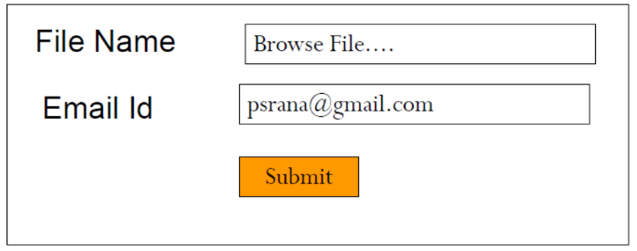

**Program 4:** Develop a web service for Program 2 (**Optional**).

